 | INSTITUTO POLITÉCNICO NACIONAL  ESCUELA SUPERIOR DE CÓMPUTO  ANALOGYC ELECTRONIC LABORATORY | 

Analogyc Electronic

PRACTICE No. 8
“Active Filters”

Group: 2CV5

N°-Team’s table: 6

TEAM: ORTEGA GARCIA FRANCISCO JAVIER
ORTEGA ARROLLO ALEJANDRO
MENDEZ VILLEGAZ JESUS EMMANUEL

TEACHER: Raúl Santillán Luna

DATE OF DEVELOPMENT: ______________________

DATE OF DELIVERY: ______________________

COMMENTS:
_______________________________________________________
_______________________________________________________
_______________________________________________________

Theoretical introduction.

Un filtro es un sistema que permite el paso de señales eléctricas a un rango de
frecuencias determinadas e impide el paso del resto.
■ Se utilizan para:
- Acondicionamiento de señal de entrada.
- Digitalización de señales.
- Acondicionamiento de señal producida.
En función a la función de transferencia se clasifican en:
- Paso Bajo
- Paso Alto
- Paso Banda
- Eliminada Banda.
En función a la tecnología.
En función al tipo de implementación.
Filtros ideales
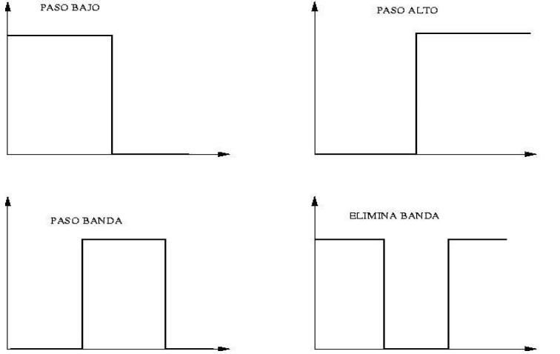

Objectives:
At the end of the practice, the student will check the operation of the different types of active filters and determine the cutoff frequency of a given filter through the amplitude of the output signal.

MATERIALS: EQUIPMENT:
1 | ProtoBoard | 1 | Power supply.
4 | TL071 ó LM741 (Amplificadores Op) | 1 | Digital multimeter.
5555 | Resistors 6.8 kΩ | 1 | Osciloscopio de propósito general
5 | Resistors 12 Ω | 1 | Generador de Funciones
3 | Resistors 15 Ω | 3 | Cables coaxiales BNC - Caiman
3 | Resistors 2 Ω | 4 | Cables CAIMAN – CAIMAN
5 | Capacitores de 0.01µF a 50 v | 3 | Cables BANANA - CAIMAN
2 | Capacitores de 0.022µF a 50 v
3 | Capacitores de 0.047µF a 50 v
2 | Capacitores de 0.01µF a 50 v

EXPERIMENTAL DEVELOPMENT

- Filtro pasa bajas
Construya el circuito que se muestra en la siguiente figura, introduzca una señal senoidal de 5 Vpp en la terminal de entrada. Varié la frecuencia del generador para encontrar la frecuencia de corte del circuito.
Anote el valor de la frecuencia de corte
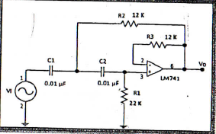
Fc= 650

10 mV/div canal 1
1 V/div canal 2
500 mseg/div
Canal 1
Canal 2

10 mV/div canal 1
1 V/div canal 2
500 mseg/div
Canal 1
Canal 2

10 mV/div canal 1
1 V/div canal 2
500 mseg/div
Canal 1
Canal 2

- Filtro pasa altas
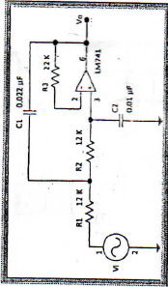
Construya el circuito que se muestra en la siguiente figura, introduzca una señal senoidal de 5Vpp en la terminal de entrada. Varié la frecuencia del generador para encontrar la frecuencia de corte del circuito.

- Filtro pasa banda

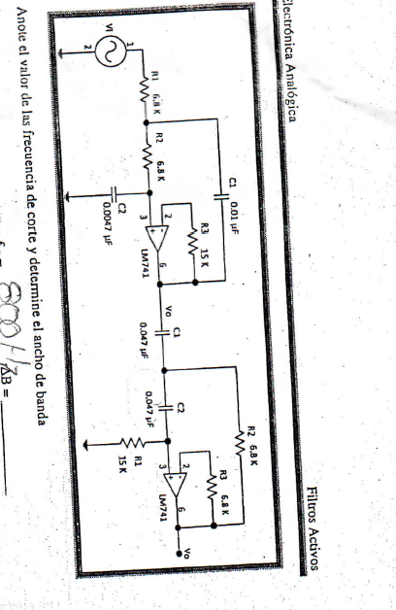

Questionary

- What is the reason for the polarization of the transistor?

The DC polarization is needed to establish the proper operating region for the amplification of AC.

- What we represents the β (beta) of the transistor?

The dc current gain of a transistor is the ratio of the dc current collector (IC) between the dc current base (IB) and is expressed as beta CD (βCD).

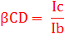

βCD typical values ranging from 20 to 200 or more.

- What we represent the α (alpha) of the transistor?

The ratio of the dc current collector (IC) between the emitter dc current (IE) is the alpha cd (αCD). Alpha is a parameter that beta less used in circuits with transistors.

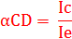

Generally αCD values ranging from 0.95-0.99 or more, although αCD is always less than 1. The reason is that IC is always slightly less than IE in an amount of IB.

- Which of the circuits previous polarization is more stable with temperature?

In the voltage divider circuit by large variations are not presented.

- Tell what is the operating point of the transistor..

The term polarization comprises everything related to the application of dc voltages, which help to establish a fixed level of current and voltage. For transistor amplifiers voltage and dc current resulting establish an operating point on the characteristics that define a region to be used for amplification of the applied signal.
Because the operating point is a fixed point on the characteristics, also called resting point (point Q abbreviated by the acronym of, quiescent point).
The bias circuit may be designed to set the device operation in either of these or other points within the active region. When the active region is confined many areas or different operating points can be selected.

CONCLUSIONS.
Ortega García Francisco Javier

In developing this practice better I understand the operation of both NPN transistors and PNP, testing the various basic circuits which we can use for a particular purpose (fixed polarization splitter, etc).
C Understanding how these devices I think is critical because many more complex circuits make use of transistors inside and know how they work from the basics allows the opportunity of entering more deeply into the subject and know that these circuits perform certain things.
On the other hand, I could see the changes both voltage and current in the transistor occurring with increasing temperature, making the visual effect of this on the device.
Now on the other side of the basic circuits, learn these different configurations help to know the changes that have one over the other, because it can be useful at some point and has more ideas in proposing a circuit with transistors.

